

Sentinus IT Bursary Placement Program

By Adam Logan and Dean Logan





**Handwriting Recognition Software**

**Abstract:**

One of the projects that we carried out was research into handwriting recognition software. This was simply to research what was the best handwriting recognition software there is available for free.

**Introduction:**

We were placed with an IT company called Fujitsu. Fujitsu has a contract with the PSNI and therefore they paired us up with the ICS (Information Communication System) team within the PSNI. When we were with the PSNI one of the projects we were given was to research different handwriting recognition software. They wanted us to do this as they are in the process of digitizing all the legacy files in an attempt to free up storage space within the PSNI. This means they wanted an accurate handwriting recognition software so that there can be as little human intervention as possible and an ability to perform some form of search for keywords within documents.

**Methods and Materials:**

For our materials we simply just used the internet to find different demos of the handwriting recognition software and any reviews of the software. We also used pages of notes to test the software.

The method for the research was just finding reviews and testing the free demos of the software for ourselves and then documenting different features and information about the software. For the research to be fair we used the same notes to test each of them.

**Results:**

Google tesseract:

* Tutorial video on how to install and use: <https://www.youtube.com/watch?v=rSKYTefQv5g>
* A benefit of google tesseract is that it is open source and therefore free to use but it does not have a search function and it is a CLI and not a GUI.
* Google tesseract can be used on multiple languages but for what the PSNI will be using this technology for it is not relevant as all files to be scanned will be in English
* The input and output of the command ‘tesseract.exe’
* Tesseract is only available as a CLI.
* Documents\20190821_124054.jpg ..outputa -l eng’ is shown below:

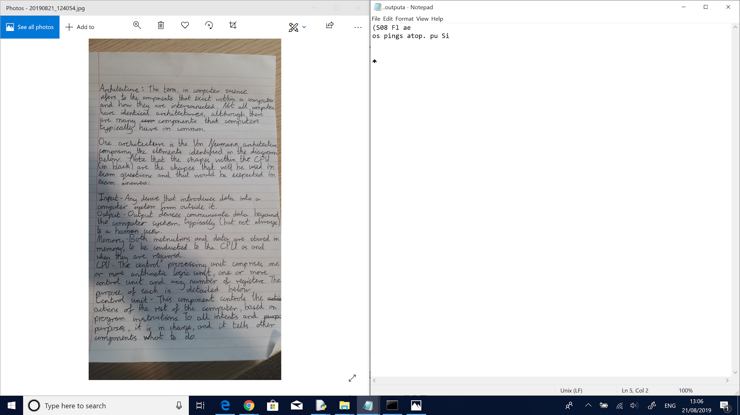

Transkribus:

* Tutorial that takes you through installation and use of the program:

<https://transkribus.eu/wiki/images/7/77/How_to_use_TRANSKRIBUS_-_10_steps.pdf>

* Transkribus offers additional documentation on all the different features here:

<https://read.transkribus.eu/transkribus/>

* Transkribus is owned by a company called READ which aims to “revolutionize access to archival documents with the support of cutting-edge technology such as Handwritten Text Recognition (HTR) and Keyword Spotting (KWS)”.
* The READ project has received funding from the European Union’s Horizon 2020 research and innovation programme under a grant agreement showing this software has promise for further development and will still receive support in the future.
* The National Archives has been running a pilot project to test Transkribus using their collection of PROB 11 wills.
* Transkribus works by first uploading a batch of training documents which will have a transcription already written for each document so the software can learn that handwriting. However, this software has already been trained using 60,000 documents containing a variety of different handwriting styles so depending on the style of handwriting in the document the software still may be accurate.
* Transkribus claims to have achieved a WER (Word Error Rate) of 39% and a CER (Character Error Rate) of 21% after passing through 15,000 documents then a WER of 28% and a CER of 14% after a further 37,000 documents were passed through.
* Before you can transcribe a document, you must first find the segmentations in the document, this is where the software believes each line is located. The process of doing this is simple and is shown in the tutorial.
* Once the segmentations are found the software will then transcribe each segment and will display the believed transcription below the image. Once you select a line in the image or the transcription the corresponding line will be highlighted in either the image or the transcription.
* Transkribus also works well with structured documents as it can learn a pattern within the documents. This software also allows for you to search for keywords in a collection of documents.
* Transkribus allows for scanned documents to be uploaded directly to it so you do not have to save each scanned image individually then upload them to transkribus. More information on how to do this is in the tutorial.
* An example is shown below with no prior training other than what is already pre-downloaded on the software: 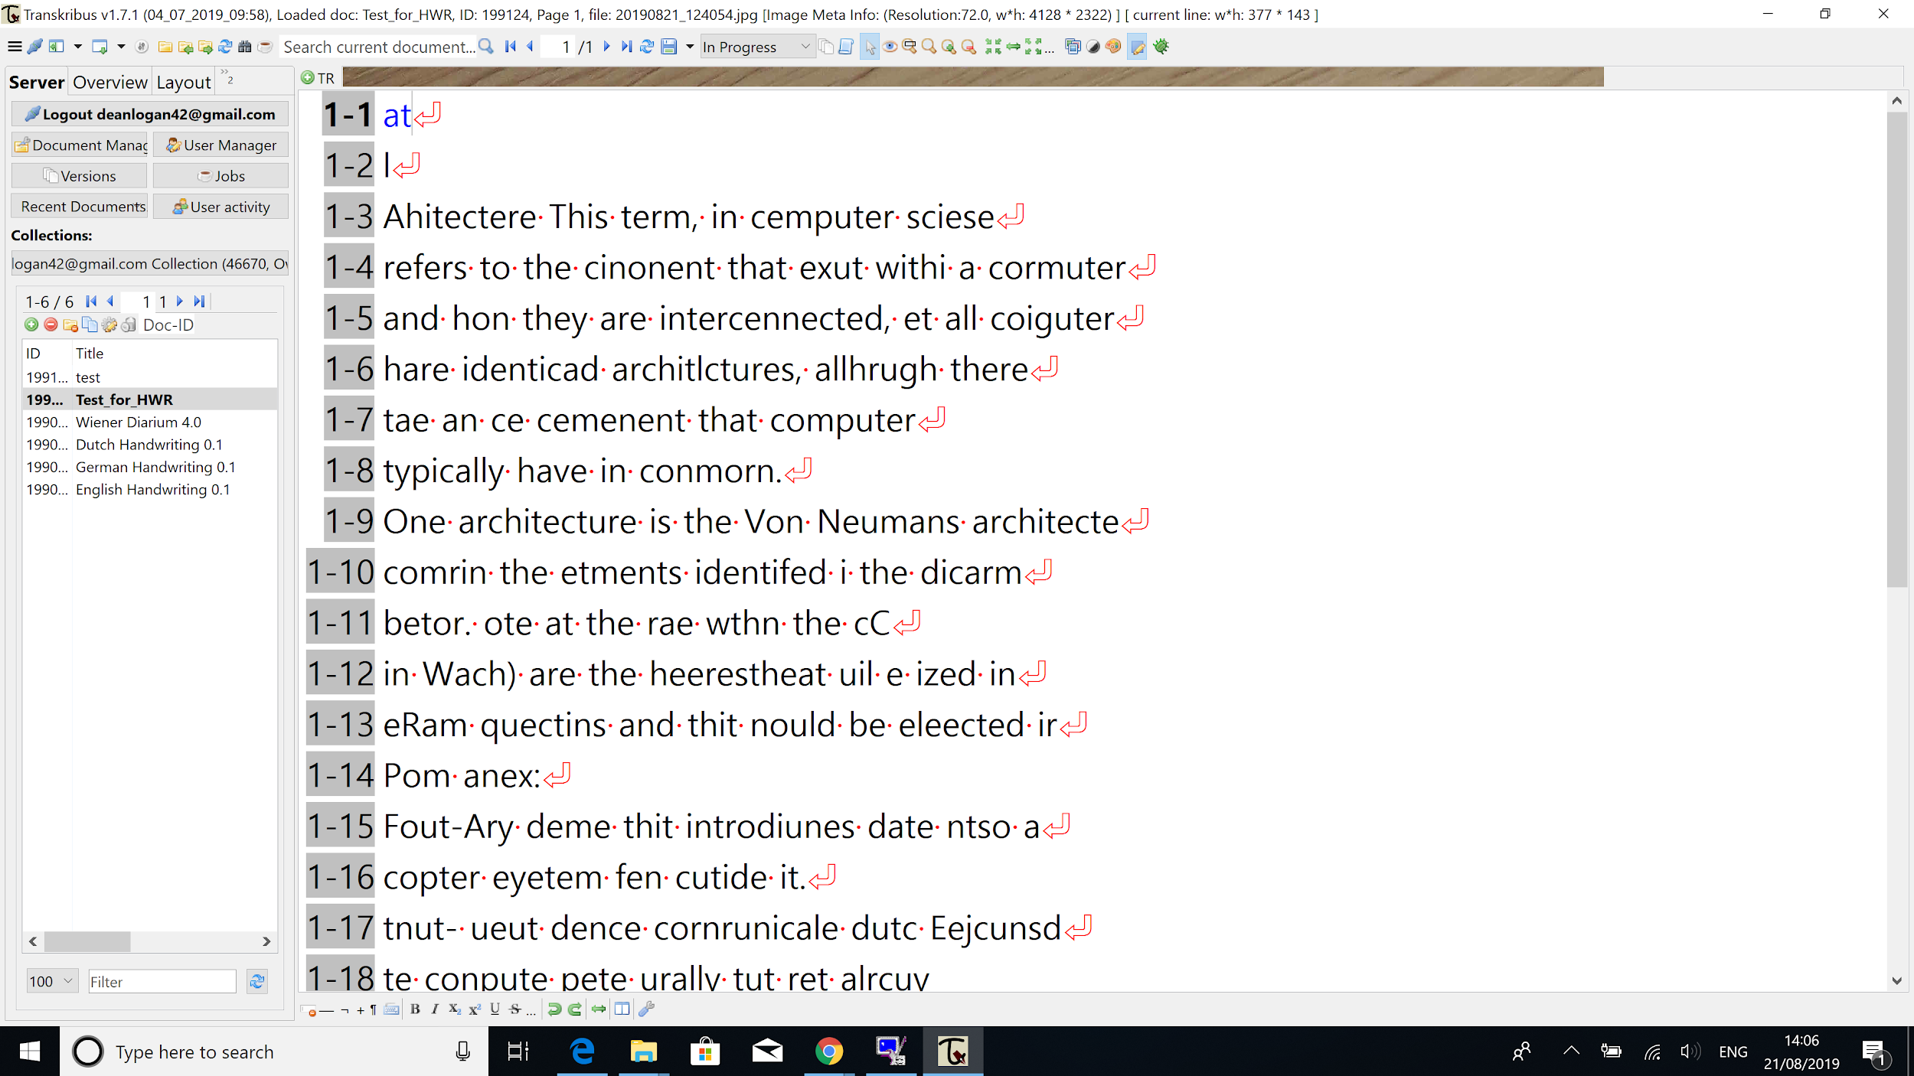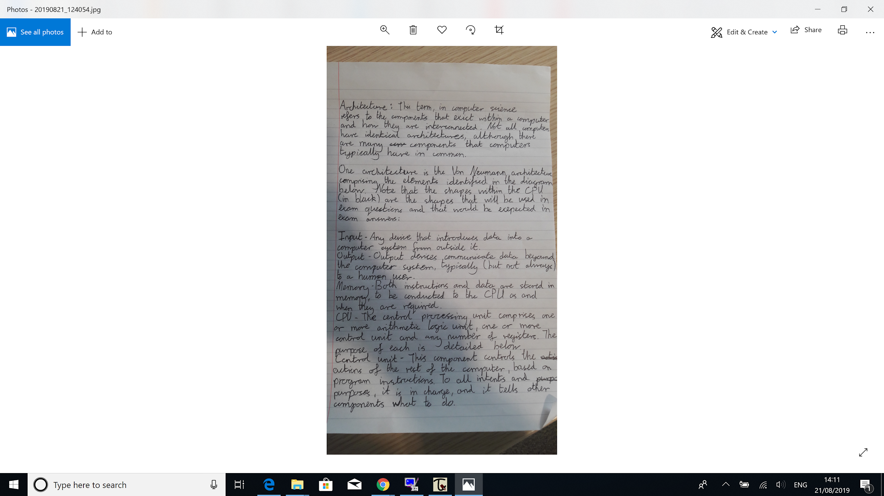

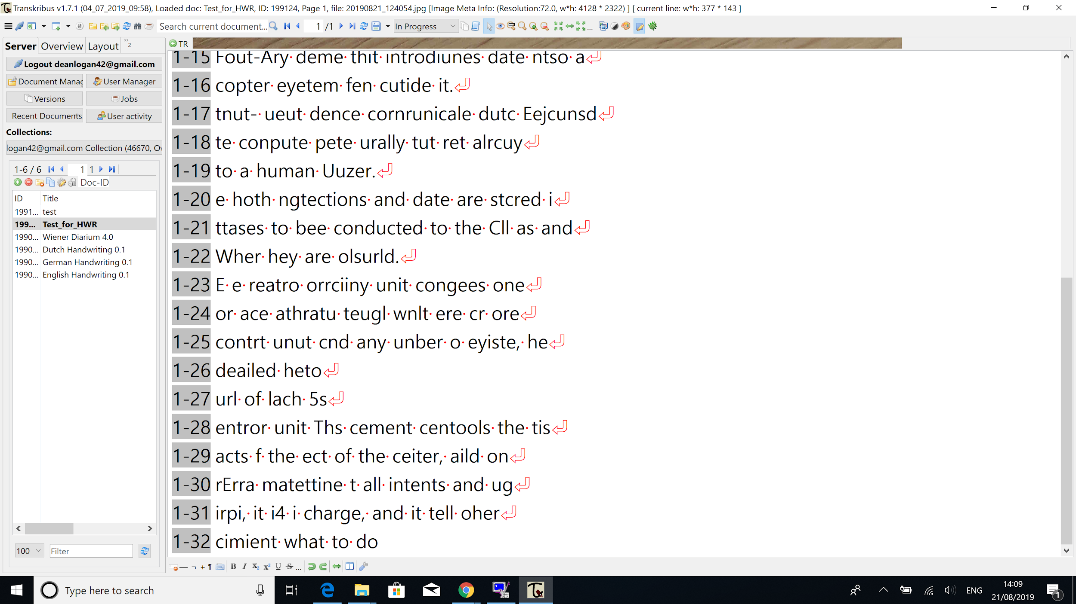

* The first 2 lines that the software thinks are “at” and “I” respectively are said to be read from the edge of the page at the top. So where the desk can be seen meeting the page. My theory is that the software is seeing the straight edge of the page as a line and the grain pattern on the desk as the words “at” and “I”.
* This is how it looks when you select a line:

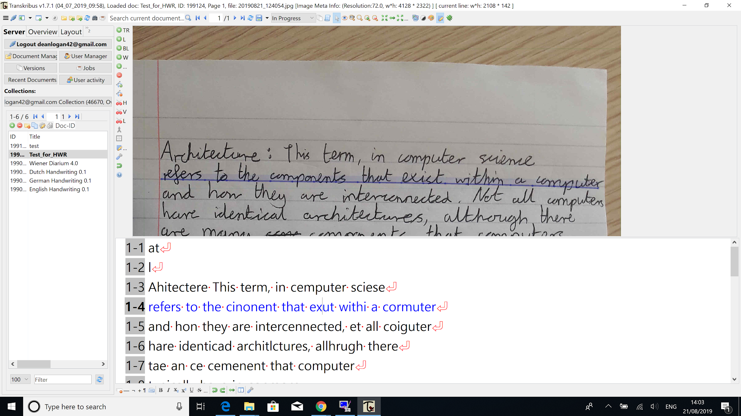

You can see where the software thinks the line is (shown as a blue line) and where the letters are (highlighted blue). You can also see the program is struggling to read certain letters but can make out the majority of them and form rough words together.

SimpleOCR:

* The tutorial for SimpleOCR is within the program itself.
* SimpleOCR requires you to create a user for every different type of handwriting you plan to pass through it so it can best identify what each word is. However, you could pass through similar handwriting into just one user and it will hopefully identify most of the words.
* This software requires some training as there is no prior training. Training the software involves uploading files (SimpleOCR recommends 3-4 A4 pages) of one person's handwriting and manually going through each transcription and fixing every word that is not correct.
* In SimpleOCR you can upload a single image file or upload image files as a batch or directly from a scanner.
* For SimpleOCR to work it first turns the image into black and white to read it. The image must be in portrait for the software to read the document, this prevents the user from uploading a batch of files and just transcribing the entire batch straight away as with all the images I uploaded they were all set to landscape by default even though the actual image file itself is portrait, so I had to rotate each image.
* After the software has transcribed a document, it colours codes the text. Black for words that it is certain it knows, blue for words it is unsure with but is fairly confident that it has got right and red is for words that it is sure that is wrong.
* When you select a word within the transcription it gives a dropdown menu of other possible words it thinks it could be.
* An example of the software in work is below (prior to the software trying to transcribe this I passed through 3 different A4 pages to train the software with the same handwriting)

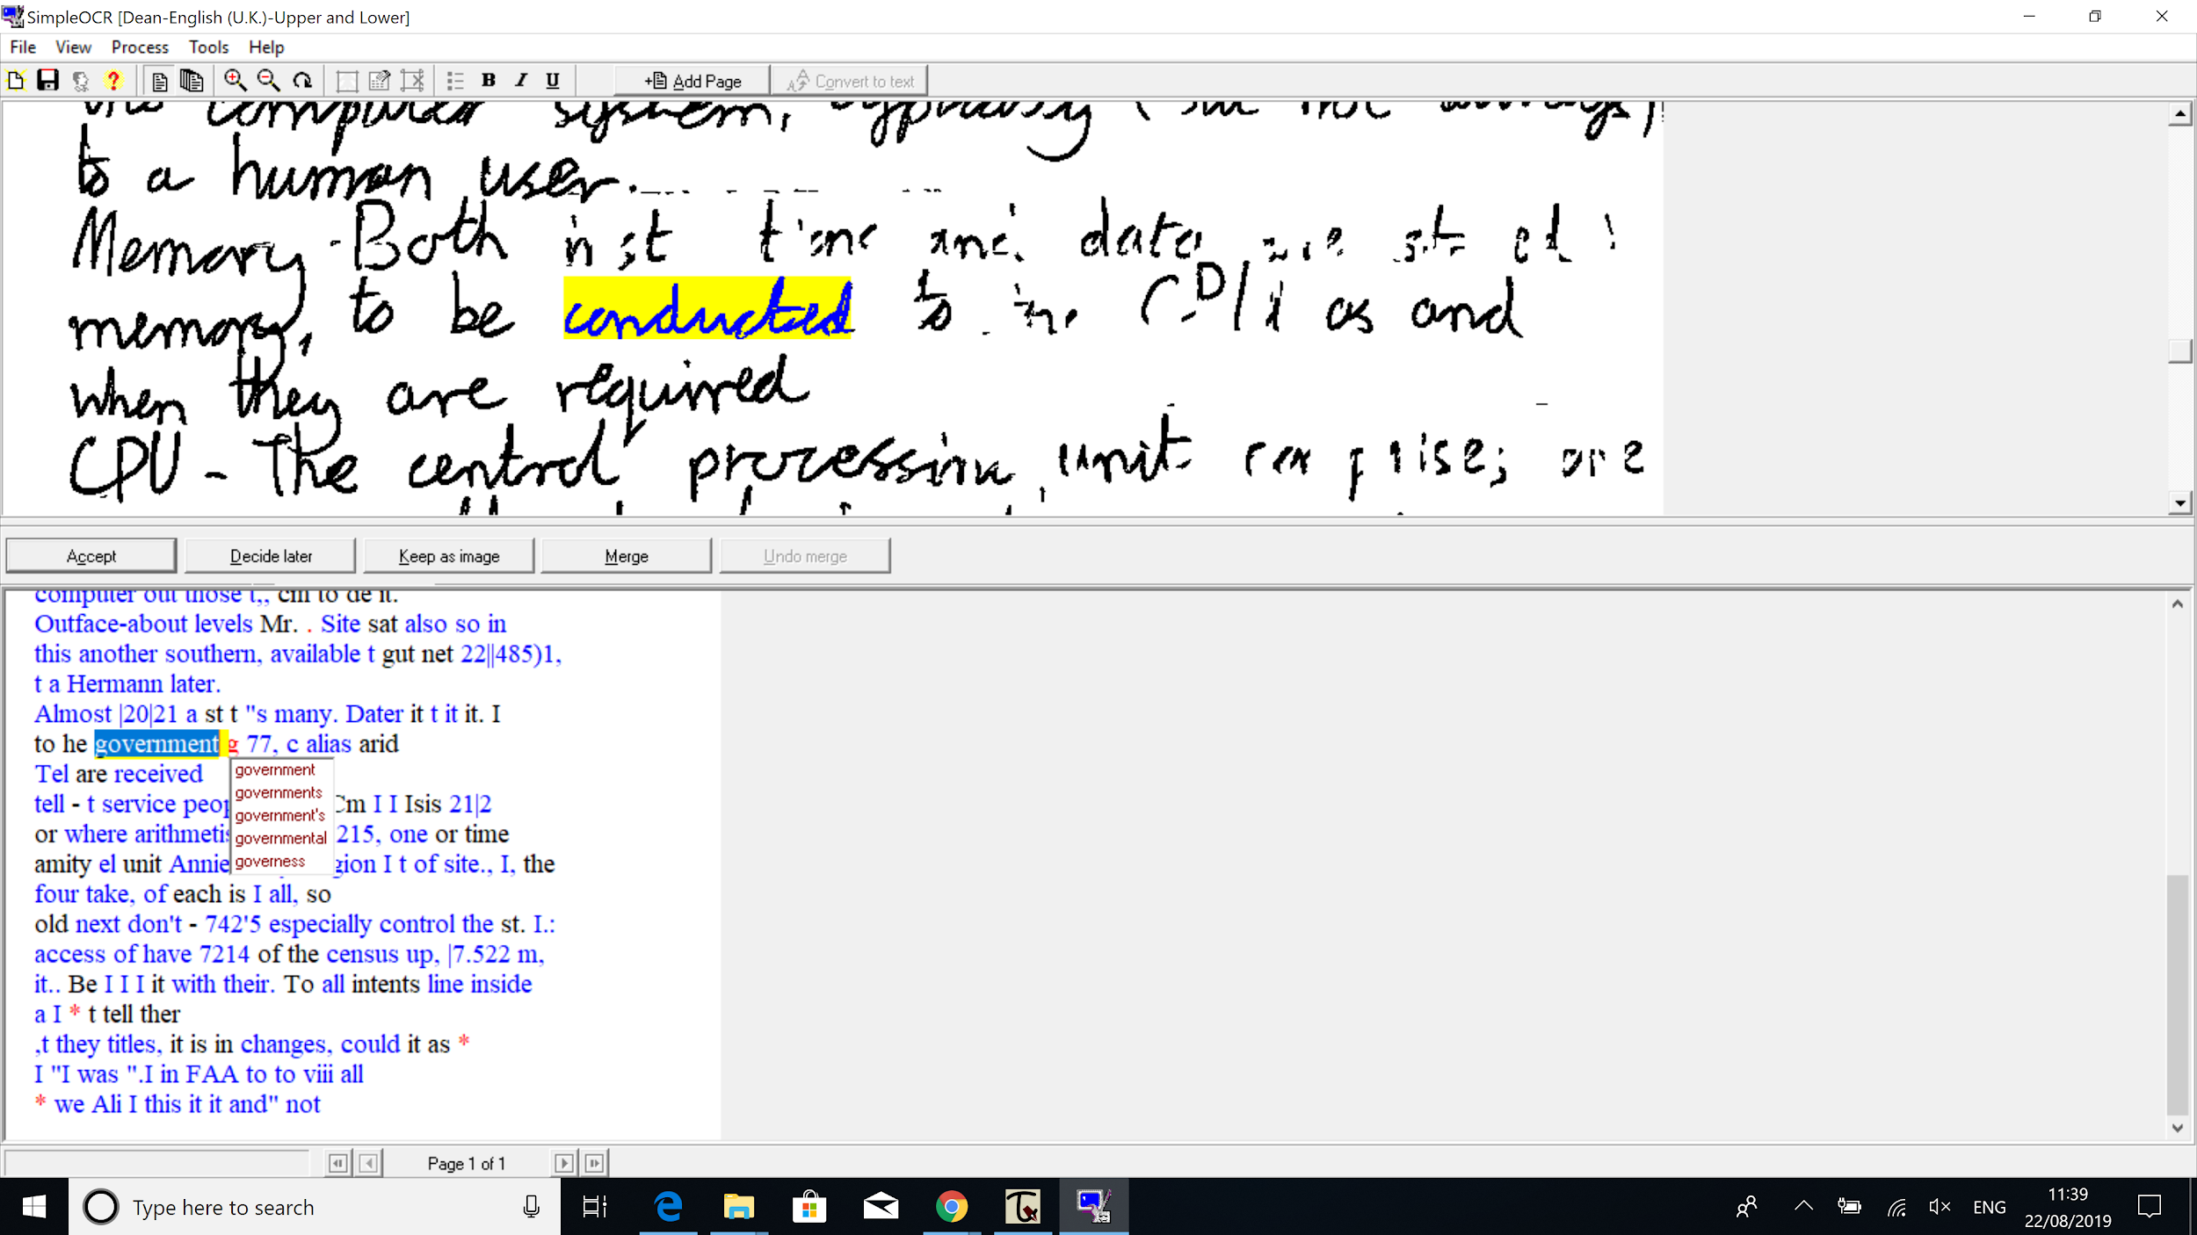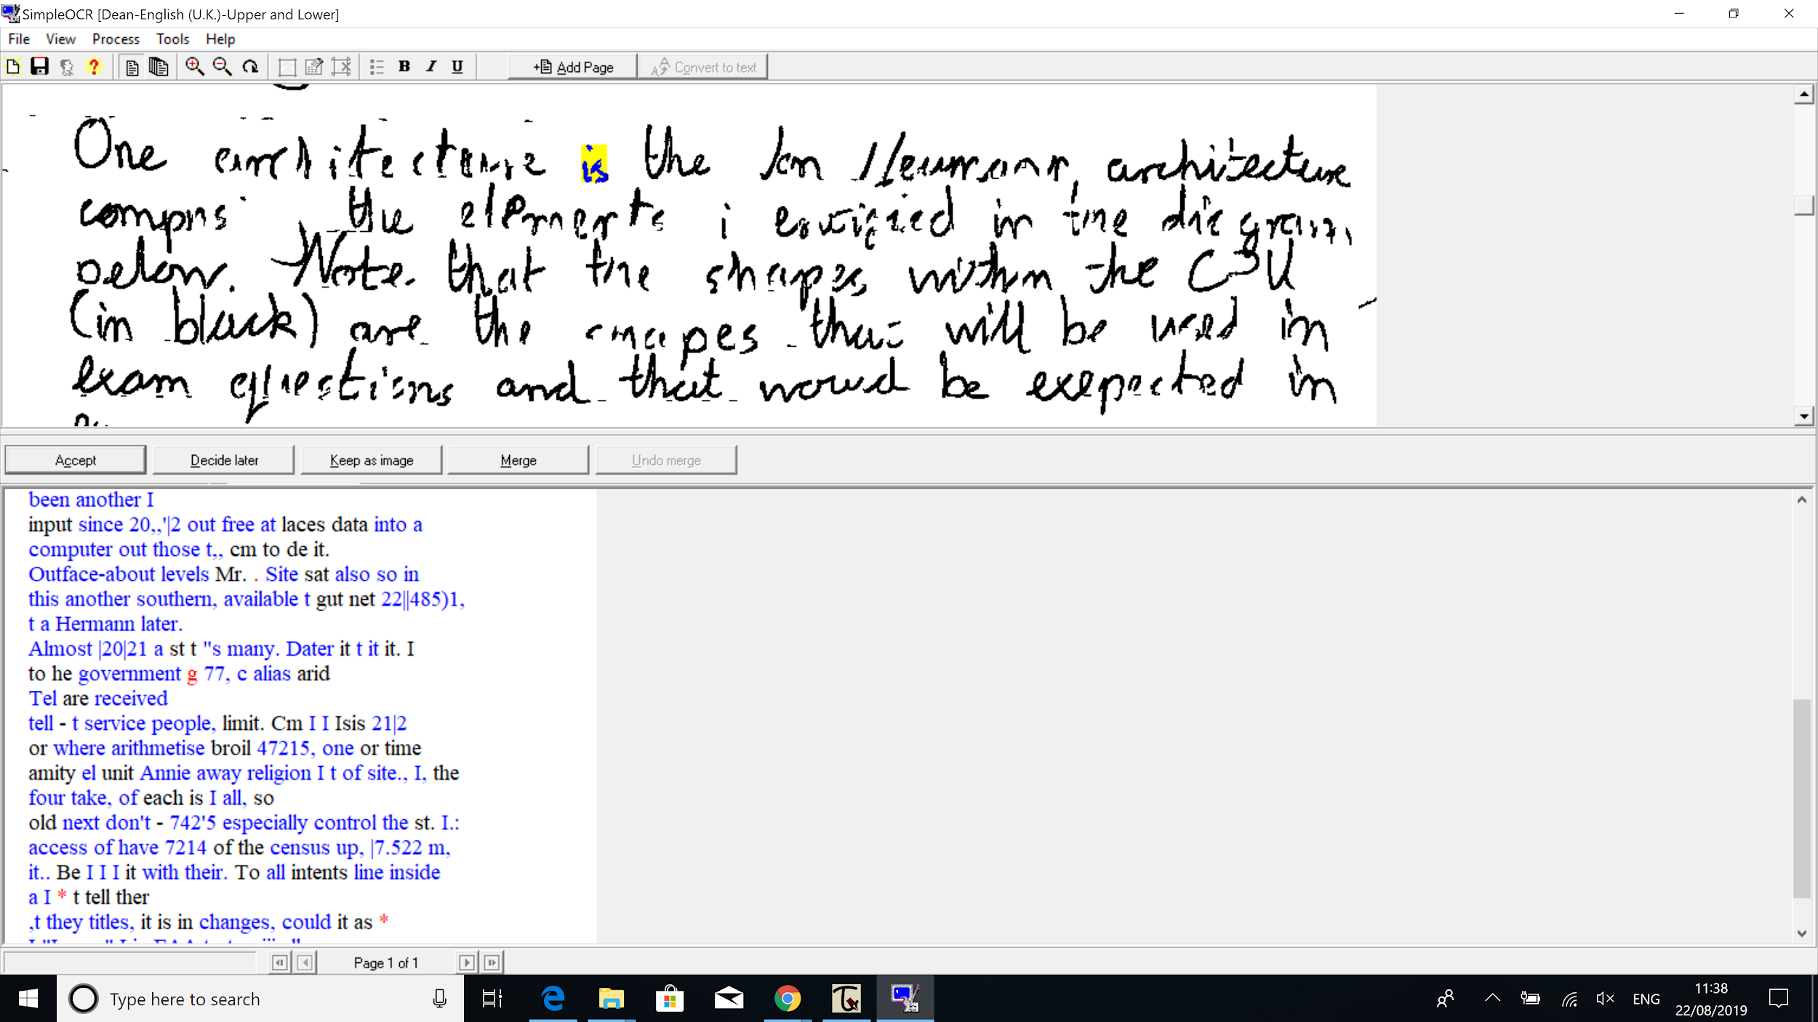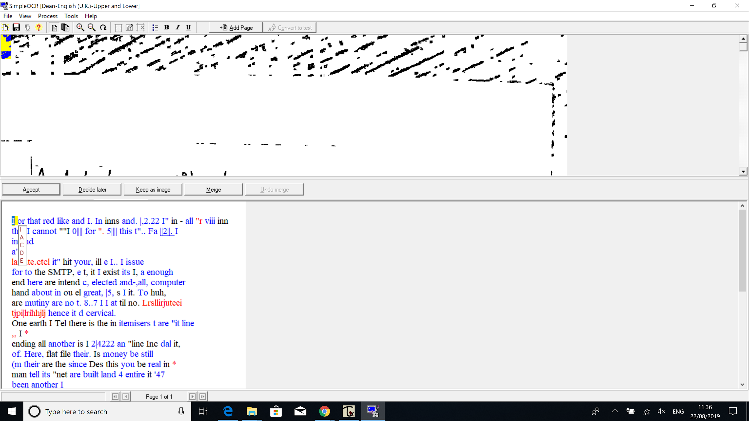

* As you can see the majority of the words are blue and even the black words are mostly wrong.
* The program has also identified multiple words on different lines as one word as seen below:

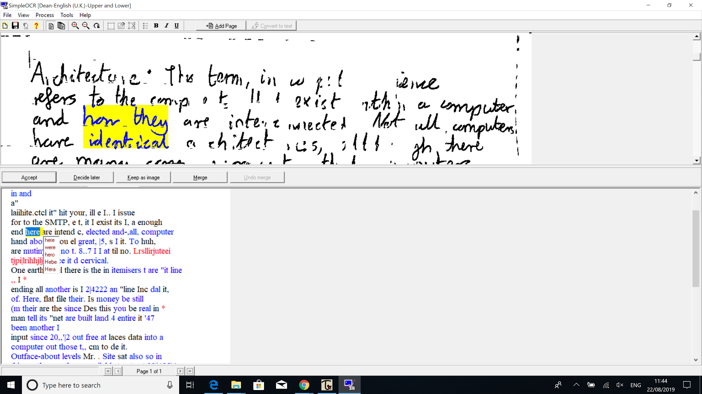

* The images I passed through are below, with these images I fixed the transcriptions so the program can learn:

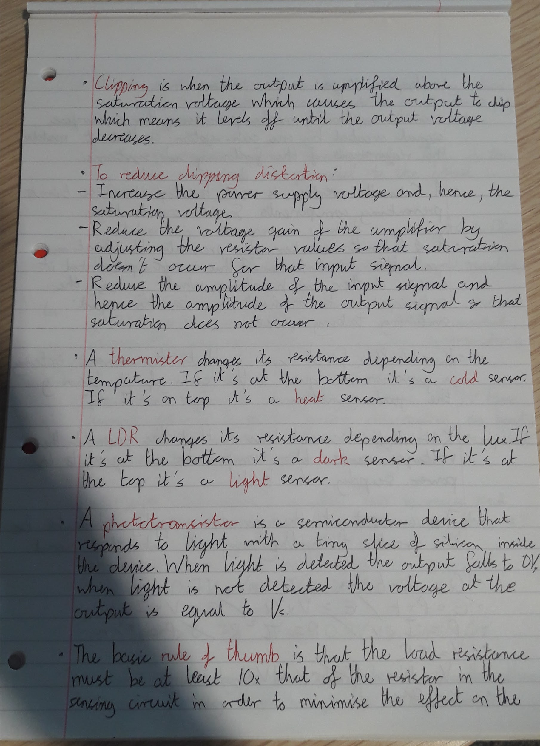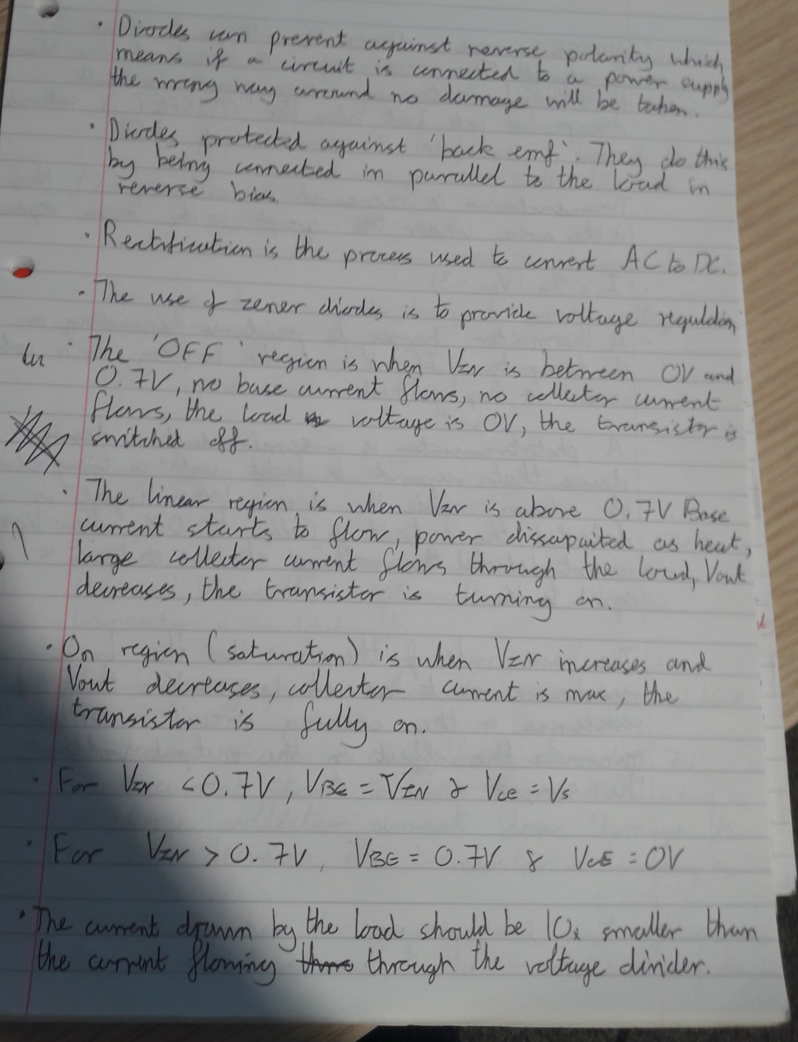

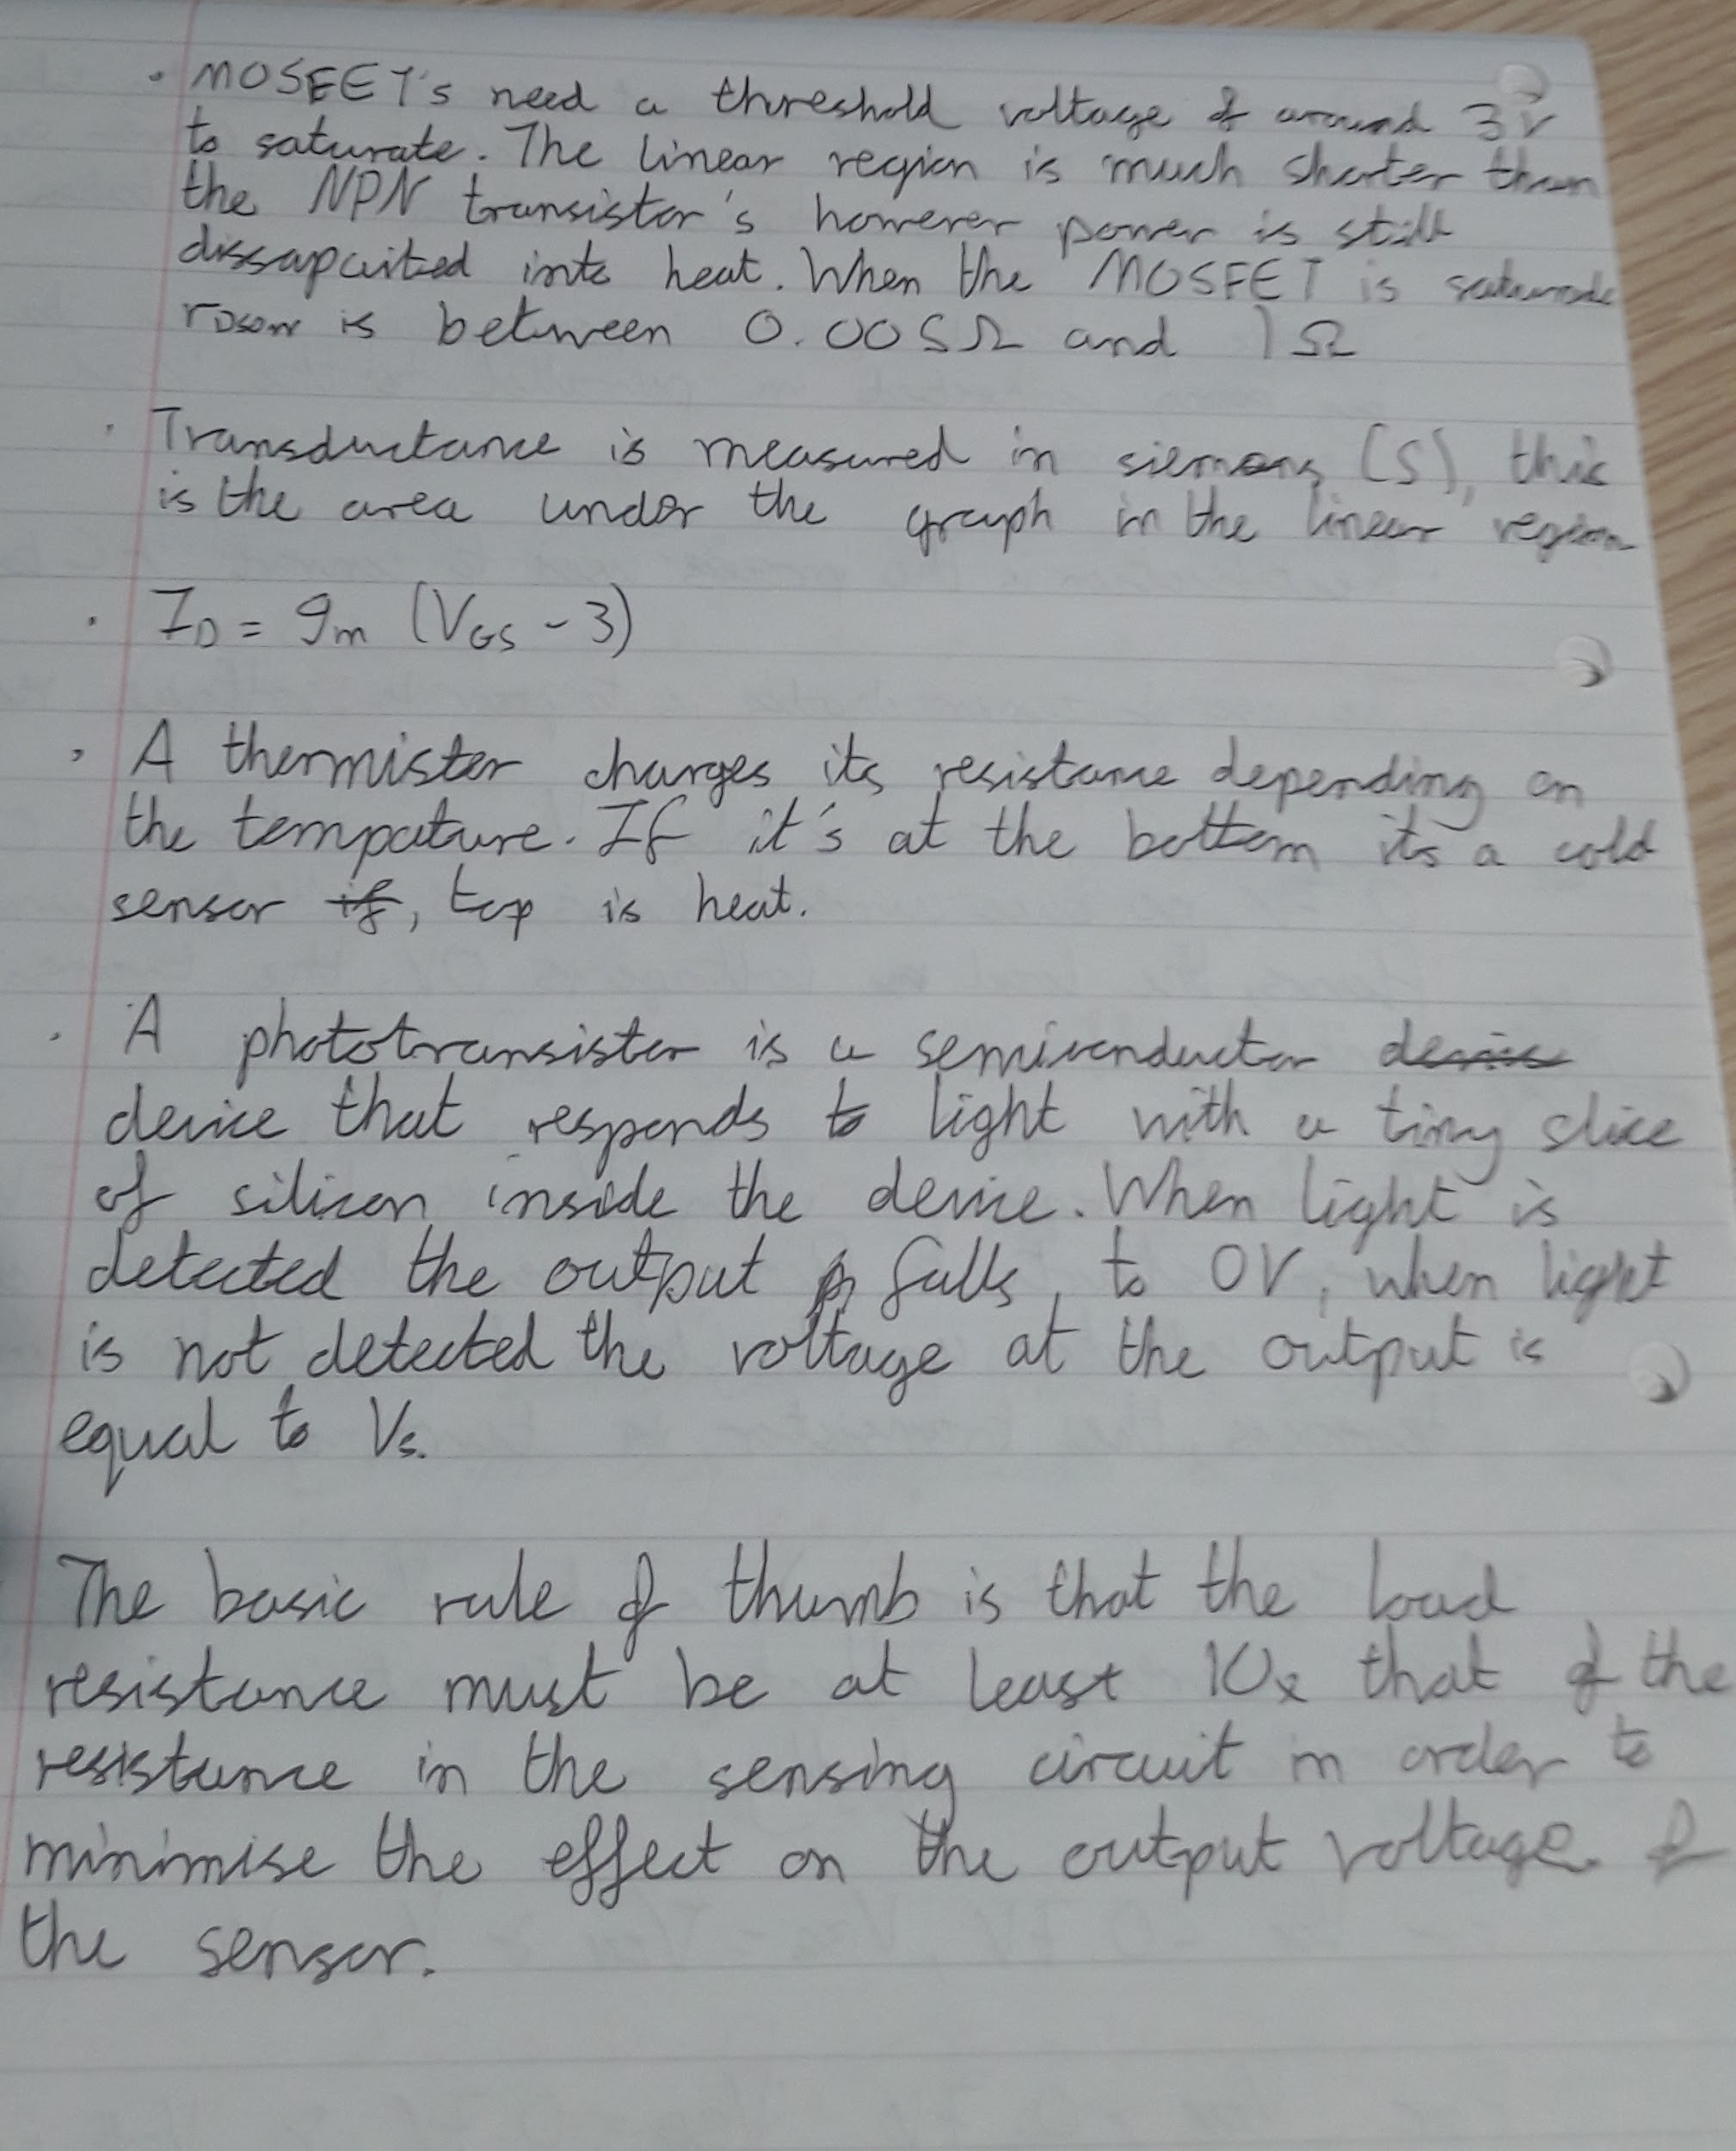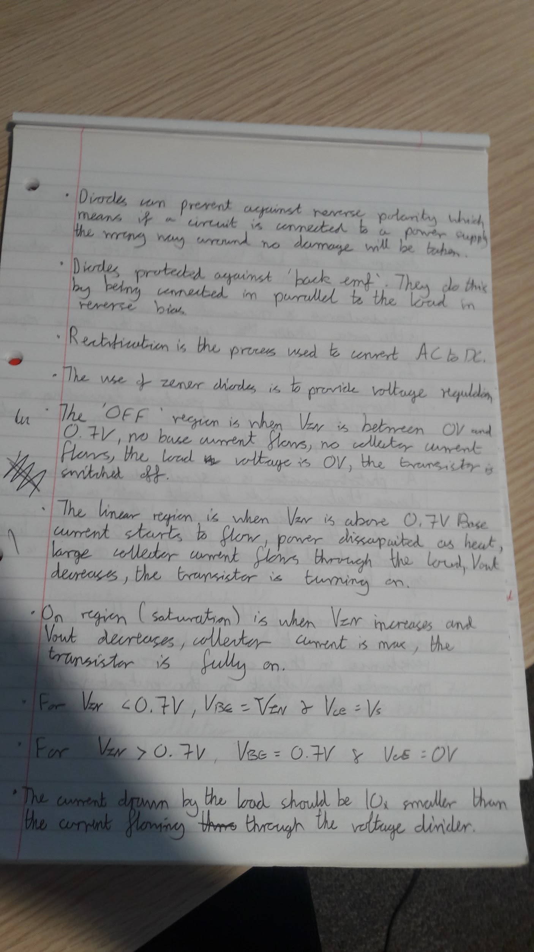

Azure:

* There is no demo available for the Azure OCR system apart from the JFK file which can be found at this link <https://jfk-demo.azurewebsites.net/#/> and therefore this is what I will be basing my analysis on.
* Azure is a cloud computing platform and therefore all the processing is done on Microsoft servers which poses the question of security.
* In 2011 Gordon Frazer, managing director of Microsoft UK at the time, stated that US officials can access data on European data centres under the Patriot Act as Microsoft's headquarters are in the US. This means that sensitive files cannot be scanned and used by this as US officials will be able to access this data by simply sending a request to Microsoft.
* Azure is the best OCR algorithm out there but it still makes mistakes, therefore there may be some human intervention needed.

**Discussion:**

In summary Transkribus will probably be the best as it is the most accurate with no prior

training needed and is the most likely to be supported in the future. It is also easy to use and

allows for a keyword search within the software as well and offers one of the best tutorials.

**Facial Recognition**

**Abstract**

This project was simply to create a facial recognition system for the PSNI. The system simply takes an image as an input and will produce another image that is stored in a specific file, which contains the individuals in the image that was taken as the input.

**Introduction**

My placement was with the PSNI and specifically in the ICS department. As stated one of the projects that we were working on was facial recognition software. The problem that we had to solve was simply to identify an individual when given a photo of them. This is useful for the PSNI as this will free up several officers from scanning through images and videos attempting to find a single person. With the current approach it is easy for someone to miss a person in a video or in the background of a photo if they are tired and have already searched through dozens of them. These problems are solved by facial recognition software as a computer will not get tired and retain the same level of accuracy no matter how many hours of video there is.

**Methods and Materials**

Methods

The main method we deployed in achieving this goal was by following the instructions of Adam Geitgey on his Lynda course ‘[Build cutting-edge facial recognition systems](https://www.lynda.com/Python-tutorials/Build-cutting-edge-facial-recognition-systems/628706/788514-4.html?srchtrk=index%3a1%0alinktypeid%3a2%0aq%3apython+facial+recognition+dlib%0apage%3a1%0as%3arelevance%0asa%3atrue%0aproducttypeid%3a2)’. This course provided the Python libraries needed to carry out the task and how to implement these. When we finished the course, we decided to combine the two main elements of the course, which was finding lookalikes and finding the same individual, into the same script. We then altered the code to make it into a CLI and we also changed the code so it would identify all individuals in the image and not just the first face it finds.

Materials:

* Laptop
* PyCharm
* [Lynda course](https://www.lynda.com/Python-tutorials/Build-cutting-edge-facial-recognition-systems/628706/788514-4.html?srchtrk=index%3a1%0alinktypeid%3a2%0aq%3apython+facial+recognition+dlib%0apage%3a1%0as%3arelevance%0asa%3atrue%0aproducttypeid%3a2)
* Python 3.6.6
* The python libraries dlib and facial_recognition

**Results**

The first part of the program we tested was the facial recognition part as this would be used the most often within the PSNI.

Input:

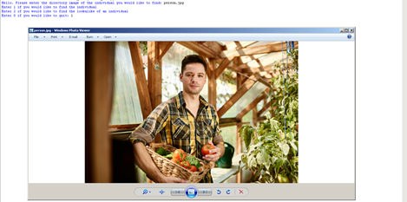

Output:

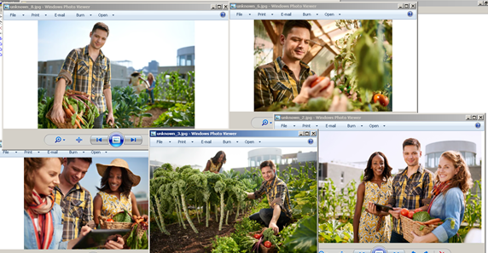

As you can see above the program appears successfully work as all the images within the file that contains the person in the input image have appeared. There were other images within the file that did not appear and none of them contained the person in the input image.

The results of the face similarity part of the program is shown below.

Input:

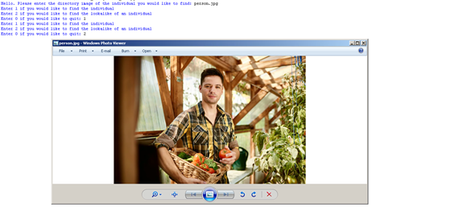

Output:

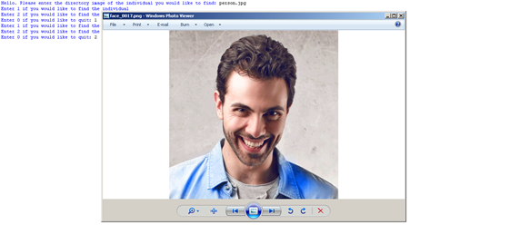

As we can see in person in the output image does look similar to the person in the input image and therefore the system works.

**Discussion**

As seen above in the ‘Results’ section the software will take an image as an input and will provide the images which contain the individual or their lookalikes, depending on the option selected, as an output.

How the facial recognition software works is that it will convert the image into greyscale and then look at a specific pixel. The software then will record the difference in lightness and darkness the surrounding pixels are, and it uses this information to find face ‘landmarks’ on the face. The system locates the landmarks through deep learning which was imported through dlib. To check if a face is the same or similar the overall face distance is calculated and compared. In every image of the same person the face distance will be slightly different due to a variety of factors such as if the face is directly facing the camera or not and the size of the face in the image. This is the reason why there is a tolerance to compare the face distance if you are checking if the same person appears in the photograph. To identify a lookalike in a database of images the face with the closest face distance to the individual in the input will be recorded.

One strength of the system is that it allows the user to pick if they would like to find a lookalike or the individual. The system will ask the user again after it has completed the task and this allows the user to either run the same command again, quit or run the other command. This is a strength of the system as if the user wants to both find a lookalike and find the individual this is possible without having to run the program again. A strength of the system over a human is that it never will get tired and it is able to spot individuals in the background better than a human can. Another strength of the system is that all the processing is done locally and therefore the system is secure.

A weakness the system has is that it is slow. As the system was slow when it only had to compare 10-90 images to a single image this means it may be too slow for the PSNI to implement as the databases they would be using there may be hundreds if not thousands of images they would need to search through. Another weakness of the system is that it requires several python libraries to be downloaded to be used and therefore some IT knowledge is required.

The code for the system is shown below:

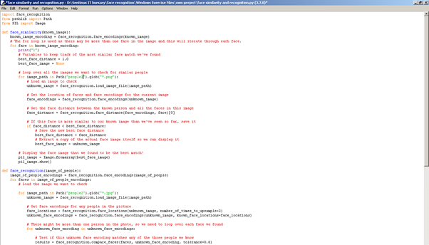

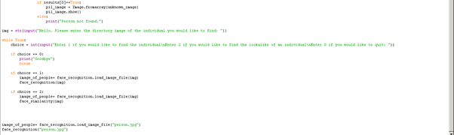

**Box API**

**Abstract**

This project was to create a program that would add records using a batch file directly onto box.

**Introduction**

Box is a secure cloud storage platform which the PSNI may use in the future to store some forms of evidence and other forms of data. Currently digital forms of data need to be saved onto an encrypted USB and then given to the individual that needs the data. This is extremely inefficient as if an officer needs information which another station has stored on their computer, then someone from that station needs to dive to the officer who requested the information. As Box is a cloud storage platform this will solve this problem as everything will be stored on box or at the very least files can be put onto box per request. Currently a record can only be added or deleted to a file one at a time but if many records need to be added to a file it would be tedious to add each record one at a time and this is the problem that we attempted to solve.

**Discussion**

Sadly, as the spreadsheet which we were working on was from HR we cannot show the results of our project. I will be able to describe what we did and what our system did. When working on the project we discovered that, using the box API, a user cannot directly edit a file on their account. When a file is edited on box the edited version of the file is saved to another account that was created with the developer account. The work around to this problem is that you can share the folder where the file resides.

A strength of our system is that it automatically connects with box and files do not need to be downloaded and edited locally. This will save time as users do not need to wait for the file to download and upload when they want to edit a file. As without using the API files need to be downloaded and then edited the file would need to be deleted from the disk manually and re-uploaded manually but using our system the user does not have to do this as it is all done automatically.

The main weakness that our system has is that the user must manually share the file with the automatically created account for the system to work. Another weakness that our system has is that it is only able to edit csv files.

**Acknowledgments**

We would like to say thank you to Laura Galloghly for helping us organise this placement with the PSNI. We would also like to thank Adam Taylor, Andrew Elwood, and Micheal for all the support that they gave us during the placement and for being so welcoming. A specific thank you to Adam Taylor and Cyber Crime for giving us a tour and letting us see what kind of work that they do. Another thank you to Cian Mulderrig for all the help he gave during the box project.

**References:**

* <https://blog.nationalarchives.gov.uk/machines-reading-the-archive-handwritten-text-recognition-software/>
* <https://read.transkribus.eu/>
* <https://www.simpleocr.com/download/>
* <https://www.makeuseof.com/tag/top-5-free-ocr-software-tools-to-convert-your-images-into-text-nb/>
* <https://github.com/tesseract-ocr/tesseract/wiki>
* <https://www.youtube.com/watch?v=rSKYTefQv5g>
* <https://www.simpleocr.com/>
* <https://jfk-demo.azurewebsites.net/#/>
* <https://en.wikipedia.org/wiki/Microsoft_Azure>
* <https://www.engadget.com/2011/06/30/microsoft-european-cloud-data-may-not-be-immune-to-the-patriot/?guccounter=1&guce_referrer=aHR0cHM6Ly9lbi53aWtpcGVkaWEub3JnLw&guce_referrer_sig=AQAAAGeKFYY94ev3D_ktlWGcR3O0cvZwZLmiKOEB9J_xfNSiy-Pu_ax-pYK29uRCuykt08jXsDxrYCvyD43LarElD5wopGLP--pRDRkBilWgrEW_3-dkwawvThqQOnd_FDTSorhFZIzI81XgI4fWUraQ10Bop_vmtWkRa4VMcR-WjqNA>
* <https://www.lynda.com/Python-tutorials/Build-cutting-edge-facial-recognition-systems/628706/788514-4.html?srchtrk=index%3a1%0alinktypeid%3a2%0aq%3apython+facial+recognition+dlib%0apage%3a1%0as%3arelevance%0asa%3atrue%0aproducttypeid%3a2>
* <https://developer.box.com/reference#upload-a-new-version-of-a-file-1>
* <https://developer.box.com/docs/construct-jwt-claim-manually#section-3-create-jwt-assertion>